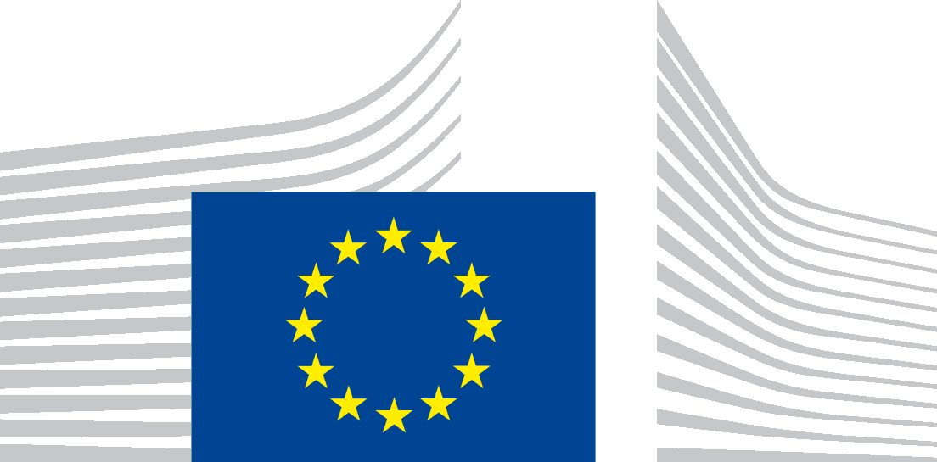
Local publication for call for proposals
Support to Civil Society capacities– Republic of Serbia
CIVIL SOCIETY FACILITY AND MEDIA PROGRAMME 2020
EuropeAid/171528/DD/ACT/RS
The Delegation of the European Union to the Republic of Serbia is seeking proposals for increasing capacities of the Serbian CSOs to address reform processes and EU integration process in the fields of environment and climate action, socio-economic development and foreign, security and defence policies in the Republic of Serbia with financial assistance from the Civil Society Facility Programme.
The full guidelines for applicants are available for consultation at on the following internet site: https://webgate.ec.europa.eu/europeaid/online-services/index.cfm?do=publi.welcome&nbPubliList=15&orderby=upd&orderbyad=Desc&searchtype=RS&aofr=171528 .
The deadline for submission of proposals is 18/05/2021, at 15:00 hrs CET.

